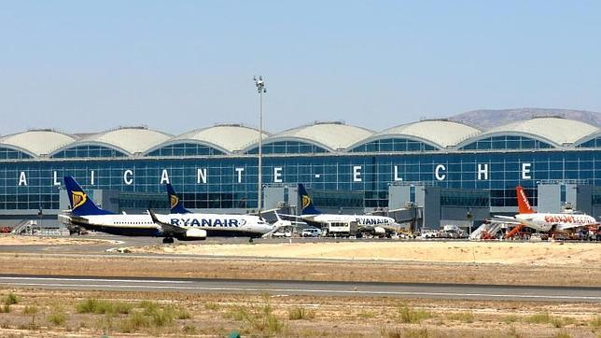
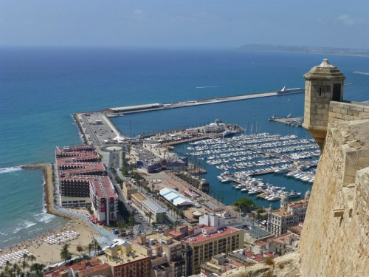
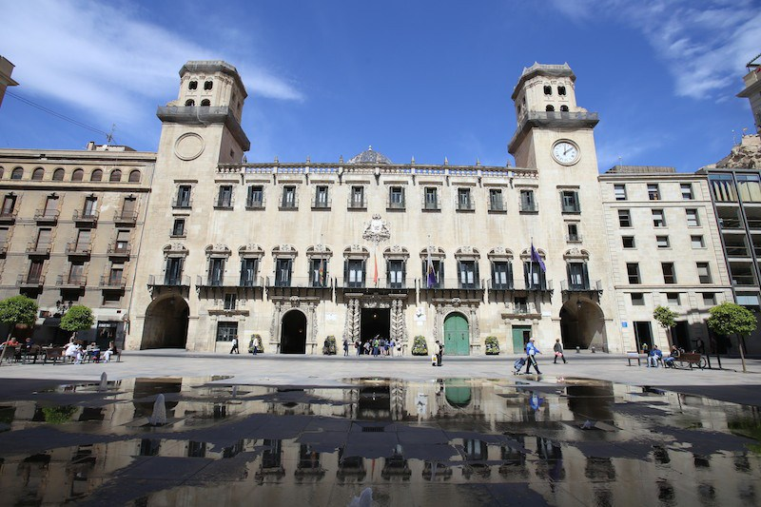
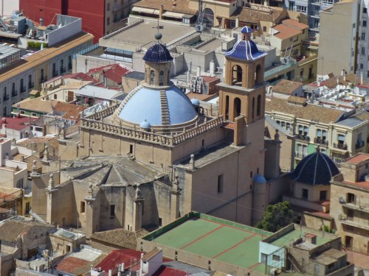
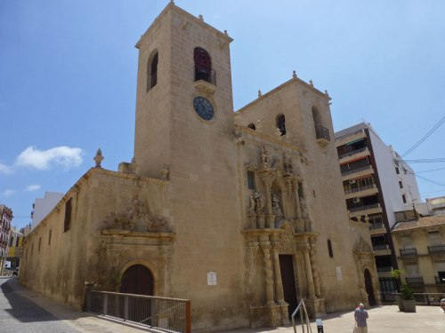
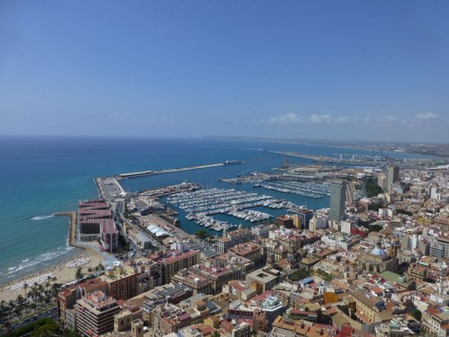
Alicante tourist guide
Belonging to the Valencian Community, Alicante is the capital of the homonymous province, co-officially its name in Valencian is Alacant. Dominating the views of the city is Castillo de Santa Bárbara, built during the Muslim domination, back in the ninth century. From there you can see the Port of Alicante in all its splendor.
http://www.alicanteturismo.com/lugares-para-descubrir/

Castle of Santa Bárbara

Perched on top of Mount Benacantil, at a height of 166 metres, stands one of Spain’s largest mediaeval fortresses, providing great views of Alicante’s perfect bay. It has three different enclosures from three distinct periods:
The upper enclosure, “La Torreta”, is where visitors will find the keep and the most ancient remains of the fortress, which mostly date from the 14th century.
Although remains of Iberians and Romans were found on its slopes, the construction of the castle dates back to the 9th century, during the Muslim occupation. It happened to have the current name with the conquest of the city by the future King Alfonso X, coinciding with the day of Santa Barbara.
http://www.alicanteturismo.com/castillo-de-santa-barbara/
Alicante's Town Hall
This baroque work of civil architectonics was designed by architect Lorenzo Chápuli and built on the site of the former city hall in the 18th century.Visitors can admire its ornamental elements such as the barley-sugar columns on the facade or its two towers. Inside there are several remarkable rooms such as the Salón Azul styled from the period of Spain’s Queen Isabel, the Salón de Plenosmeeting hall and a chapel in which mass is held. Throughout the various rooms in the building, visitors can admire interesting works by Padilla, Cabrera, Amorós and Alicante’s own Gastón Castelló.

San Nicolás' Cathedral Construction began on the St. Nicholas Co-Cathedral in the year 1600, replacing a building that had stood their previous. It is built in the Herrerian renaissance style and is located in the heart of the city. Its floor plan is in the shape of a Latin cross, with an interior that boasts remarkable features such as the 15th century cloister with two baroque doors, the altar and the blue dome 45 meters high. Below the cupola is the Chapel of Communion communion chapel, which is considered to be one of the most beautiful examples of Spanish baroque.
The interior has been restored to mark the celebration of the Light of the Images exhibition (The Light of Images) in Alicante, which aims to recover and promote the Region of Valencia's artistic heritage.
http://www.alicanteturismo.com/san-nicolas/

The Santa María Basílica
Located in the center of the city, very close to the Cathedral of San Nicolás de Bari and the City Hall of Alicante, the Basilica of Santa María was built on the remains of the Arab Mosque. Being the oldest church that is conserved in the city, it managed to ascend to the rank of basilica in the year 2007.
Its Gothic construction began in the fourteenth century, although after a fire had to be rebuilt the facade, but this time following a baroque style. In her it emphasizes the cover with an image of the Virgin, work of the architect Juan Bautista Borja. From the outside, it is also worth noting that although its towers look the same, they are not, the oldest one, from the 14th century, is L-shaped and the last, built in the 18th century, has a rectangular shape.
http://www.alicanteturismo.com/basilica-de-santa-maria/
Alicante's Museums Provincial Archaeological Museum (MARQ), a review of the history and life of the different civilizations that have occupied the Mediterranean Coast for centuries. It is located in the old San Juan de Dios Hospital.
http://www.alicanteturismo.com/museo-de-bellas-artes-gravina-mubag

Alicante's beaches Alicante has a large number of beaches that represent one of its main tourist attractions. Year after year they receive the recognition of the European Union with Blue Flags that confer them a deserved international prestige; considering itself the best beaches on the Mediterranean coast.
http://www.alicanteturismo.com/descubre-alicante/mejores-playas/

Alicante's Port Being a city that has been overturned in its relationship with the sea for centuries, it is normal that the Port of Alicante has become the heart of the city. It is one of the best places to take a pleasant walk by the sea, seeing the hundreds of boats and yachts of all sizes that are moored in the calm waters of the port, to finish the visit in one of the leisure places that offer to eat and drink enjoying the best views of Alicante. Parallel to the port runs the Explanada de España, a colorful promenade flanked by hundreds of palm trees that bring a pleasant coolness to a summer walk.
Airport
The airport of Alicante-Elche , also known popularly as El Altet airport, is a Spanish airport of Aena that is located 8 km southwest of Alicante. It is located in the municipality of Elche, 10 km east of its town center, between the districts of El Altet and Torrellano. Due to its location, this airport serves a large part of the Spanish Levante. Traditionally it has had an important charter traffic, currently most of the traffic is regular and international.

It occupies the fifth place in the Spanish airport network according to the number of passengers, after the airports of Madrid-Barajas, Barcelona, Palma de Mallorca and Malaga-Costa del Sol and is among the 50 with the highest traffic within Europe. After the statistical results of the month of December 2010, it occupies the fortieth position in the European airport network according to the number of passengers. It also represents the airport with the highest passenger traffic in the Valencian Community.

AROUND ALICANTE Altea Town

Location, economy and population.

Only 10 minutes from Benidorm, is what is possibly one of the most beautiful towns of the Costa Blanca: Altea. Nestled on a hill, it is characterized by its coastline full of small white houses, narrow cobblestone streets that end up in the sea, and the blue domes of its main church, visible from many points around.

Its foreign population is very high, according to data from the INE of 2008, almost 34% of them come from the European Union. It is also a town whose standard of living is somewhat higher than the neighboring towns, even Benidorm. Although its main economic sector is tourism, other important sources of income are fishing and agriculture, with large fields of medlars and oranges. Due to its population growth in recent years, the construction sector has been very important and has had its golden years until not long ago.
http://visitaltea.es/descubre
Elche City
The thousand-year-old city offers much more than travelers usually expect. Three properties inscribed in the different categories of UNESCO World Heritage, the Historic Palm Grove, the Misteri d'Elx and the Pusol Museum. Its beaches, natural spaces, culture, gastronomy, parties, shopping and a wide range of leisure activities make it a unique destination in the Mediterranean.
http://www.visitelche.com/patrimonios-de-la-humanidad/palmeral-de-elche/
http://www.visitelche.com/

Benidorm City
Located in the province of Alicante, forming part of the Valencian Community and on the shore of the Mediterranean Sea, Benidorm has a privileged situation that has endowed it with a special microclimate, of sweet and temperate winters and of summer tempered by the sea breeze, that allow the enjoyment of a nature that has been combined, wisely, with the emergence of a modern and comfortable city. Its particular geographical configuration makes the mountains that surround it: Sierra Helada, by the East; Aitana by the North and the Tossal de la Cala by the West, protect it from the action of the winds that could alter its pleasant weather.
http://www.benidorm.es/turismo/

